ФІЛІПП’’ЄВА Т.І.

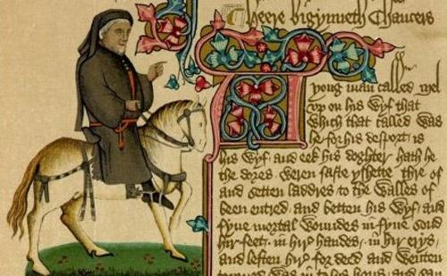

Reading in the History of the English Language
With Exercises

МИКОЛАІВ - 2013

УДК
81.001.4

Рекомендовано до друку рішенням Вченої ради Миколаївського національного університету імені В.О.Сухомлинського (протокол № від 2013 року)

Рецензети:

Філіпп’єва Т.І. Методичні рекомендації з курсу «Історія англійської мови» - Reading in the History of the English Language With ExercisesМиколаі,2013 83 с.

Content

Comprehension strategies.
- English was not imported by the Anglo-Saxons.
- Changing languages
- Social pressure and promotion.
- The supposedly closest languages are not the closest.

Precis writing.
- Language borders in Europe
- Dialects and imported languages
- How many Anglo-Saxons came over?
- Why Anglo-Saxons?
- The events before the 5th century
- It began with PIE
- Two languages emerge in Britain.
- Indo-European Linguistics

Comprehension strategies.

Text 1. English was not imported by the Anglo-Saxons!

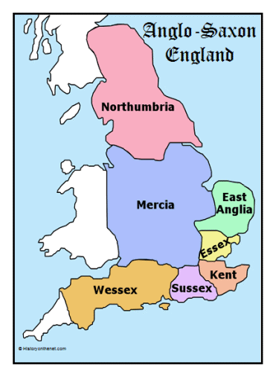

Part I.
This is how the events of the 5th century AD and the origin of the English language are declared in every history book, in every schoolbook, worldwide:
The Anglo-Saxons imported the English language in the 5th century into Britain. The Anglo-Saxons were initially invited as mercenaries. When their wages could not be paid, they rebelled and took over the east of Britain. The Britons reacted by fighting bravely, but their efforts were hampered by treachery and unlawful collaboration with the enemy by some of their most high ranking members. Eventually the Anglo-Saxons managed to subdue the eastern population. They imposed their culture and language. A major part of the population fled west where the British resistance proved to be successful for a while.
Part II.
So much for the official story. But official history has several major inconsistencies:
- Strangely enough, no contemporary source mentions a language change.
- English should have far more words of Welsh origin. Why can we not explain many place-names east of the Pennines in Welsh (e.g. London) nor in Latin? Why was there no similar language change on the continent after the collapse of the Roman Empire?
- How could a very limited number of Anglo-Saxons conquer most of England? Is it true that the British were cowards as Gildas wrote in the 6th century?
- Did the Anglo-Saxons wipe out the eastern population in Britain? Or was the entire population chased to Wales? How were the Anglo-Saxons able to replace 2.5 million eastern Britons?
- Did east-England change its language twice within approximately1000 years? Why was the alleged language transition so record-breakingly swift?
St. Gildas Badonicus (AD 500-570)
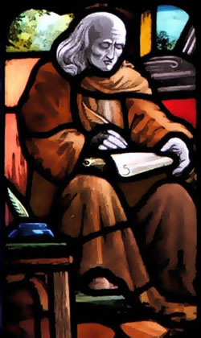
Professor Simon James (University of Leicester) reminds us that the theory of the introduction of English was established in the 17th century under James I to suit the political needs of the time. The union of the crowns of Scotland and England was explained as re-union of (Celtic) Britain. State paid historians stated that Britain was ‘Celtic’ before the Roman age. This implied the existence of a Celtic language all over Britain. The theory was used to quieten the critics who were against unification. The latter argued that the Scots always had been the eternal enemies of the English. The English language was explained as an 'unfortunate and imported accident'.
King James I of England and VI of Scotland 1621
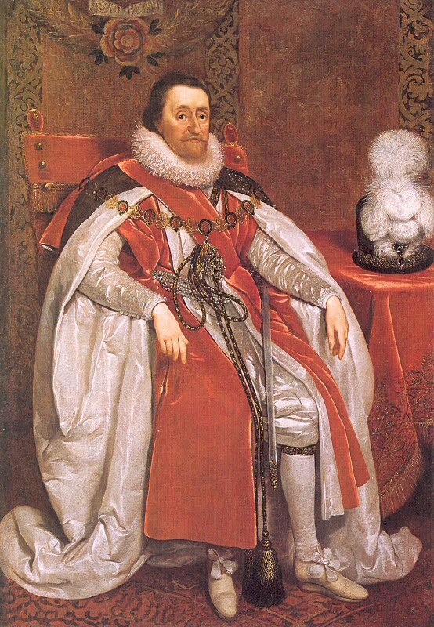
Let there be no doubt: there is no historical proof whatsoever that the Anglo-Saxons imported English. We will also challenge the very existence of Celts as a distinct people with a distinct language, but not the existence of a Celtic culture. We discovered a seriously faulty circular reasoning that is used by modern historians who are specialized in Celtic language, history and culture.
Stating that (proto) English was there all the time not only explains much better what happened during the 5th century, plus later events, and the modern situation, it also can predict a number of facts. Assuming 2 languages in Britain, the 5th century puzzle can be solved and the modern situation makes far more sense.
A warning for students: this new version of the origin of the English language is not (yet) the official one. (http://www.proto-english.org/)
Tasks.
Task 1. Arrange the words to form a sentence.
- the Anglo-Saxons, into Britain, the English language, imported, in the 5th century.
- Rebelled, took ,the east, they, and, over, of Britain.
- by fighting bravely, reacted, the Britons.
- their, imposed, and, they, culture, language.
- of the population, a major part, west, fled
Task 2. Answer these questions in short simple sentences. Your answers must follow each other so that all your sentences will form a complete paragraph. Your paragraph will be a précis of the piece.
- Does any contemporary source mention a language change?
- Can we explain many place-names east of the Pennines in Welsh or in Latin?
- What did Gildas write about the British in the 6th century?
- Was the alleged language transition so record-breakingly swift?
- When was theory of the introduction of English established?
- Why was theory of the introduction of English established?
- What implied the existence of a Celtic language all over Britain.
- Is there any historical proof that the Anglo-Saxons imported English?
- How can the 5th century puzzle be solved?
- On what conditions does the modern situation make far more sense?
Task 3. Explain the meaning of the words and phrases given below as they are used in the text:
to import; initially; a mercenary; wages; to rebel; bravely, efforts; to hamper; treachery; collaboration; high ranking member; to subdue; impose; resistance; to prove to be successful, the official story; official history; inconsistency; a language change; place-names; the collapse of the Roman Empire; to conquer; a coward; to wipe out; to chase; to replace; the alleged language transition; record-breakingly; to suit the political needs of the time; re-union of (Celtic) Britain; the existence of a Celtic language; quieten; 'unfortunate and imported accident'; a historical proof; to challenge the very existence of Celts; a seriously faulty circular reasoning; predict a number of facts.
Task 4. Join the following sentences using the connecting words in brackets.
- The Anglo-Saxons imported the English language in the 5th century into Britain. The Anglo-Saxons were initially invited as mercenaries. (as).
- Their wages could not be paid. The Anglo-Saxons rebelled and took over the east of Britain. (when).
- The Britons reacted by fighting bravely. their efforts were hampered. (but).
- It is strangely enough. No contemporary source mentions a language change. (but).
- There was no similar language change on the continent. The Roman Empire collapsed. (after).
- The theory was used to quieten the critics. The critics were against unification. (who).
Task 5. Read the first part of the text and say what the official story of the origin of English is.
Task 6. Search for information on the Internet to answer the five provocative questions in the text, if any.
Task 7. Try to answer the questions:
- What do you know of Professor Simon James? How did he explain the introduction of English into Britain?
- What was the political situation in Britain at that time?
- By whom and why was the English language explained as an 'unfortunate and imported accident'?
- What are the challenges the author of the story has concerning Celts?
- Do they believe the Celtic culture existed?
- How many languages in the 5th century Britain does the author assume to be in use?
- Is this new version of the origin of the English language the official one?
Task 8. Make up a plan of the story.
Task 9. Speak on the theme of the story using the words given below.
- mercenary, n. – найманець;
- rebel, v. - піднімати повстання;
- take over, v. - захопити владу;
- hamper,v. – утрудняти
- treachery,n. – зрада;
- subdue, v. – підкоряти;
- inconsistency, n. - несумісність;
- chase, v. – гнатись;
- alleged, a. - який стверджується
- record-breakingly, adv. – рекордно;
- quieten, v. – заспокоювати;
- distinct, a. – ясний, виразний;
- predict, v. – пророкувати;
- assume, v. – припускати.
- puzzle,v. – заплутувати.

Task 10. Do you know what it is? Search for information on the Internet about Celtic rattleback.

Celtic rattleback

Text 2. Changing languages.
Most peoples believe they are the center of the world. Other peoples are considered less valuable, so any foreign language is second-class to their own. This is certainly true for well-established and dominant peoples in Europe. The French consider their language as the most cultured in the world, so do the Germans and of course the English. We can also speak about a French language universe, an English language universe, etc. People within such a universe have difficulty imagining that there are other languages in the world. Everything clearly happens within their own universe. Only smaller populations, who have more tradition in foreign languages, are more likely to escape from this rather narrow view of the world.
Dominant peoples gladly believe that others should change their language into a more civilized language, which is of course their own. Some Americans believe that the main language in India or in Hong Kong is English. But that’s not true. It is true that many people worldwide do speak English as a first language, or learned English as a second language.
Part of a multilingual welcoming signboard at the former KCR East Tsim Sha Tsui Station. (From the top: French, Japanese, Spanish and Korean).
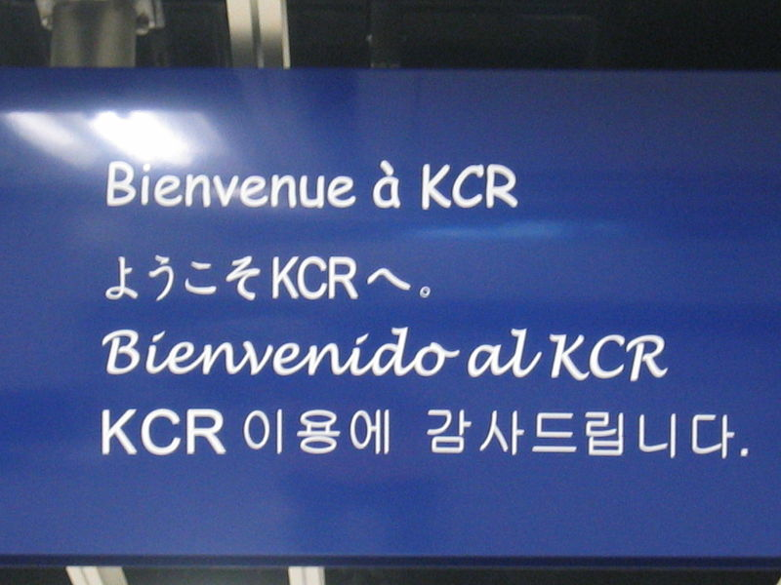

Road signs in Hong Kong are written in both Chinese and English.
But this does not mean that this foreign language is used on a daily basis in the kitchen. When a language is spoken in the kitchen then one knows that it is still very much alive. It is not easy to force entire populations to change their daily language. However, there are some examples in history of populations who changed their languages.
Time frame
How long does a language need to change completely? Note that languages evolve but never into an imposed, foreign language. A foreign language has to be learned. Let’s consider some examples.
* During 800 years the English language imposed itself in Ireland and most of the Irish saw no issue here. It worked: today the majority speaks English in daily life. Nevertheless, according to census figures released by the Central Statistics Office in 2004, out of the Republic's 4,2 million residents, there are approximately 1.6 million who regard themselves as competent in Irish. Of these, 350000 reported using Irish every day, 155000 weekly, 585000 less often, 460000 never, and 30000 didn't state how often. Of the 350000 who were reported to use Irish every day, the majority are schoolchildren who use it during their classes in Irish. The number of people in the Gaeltacht region of Ireland who use the language as their daily mother tongue has been variously cited as 70000 and 83000. When Ireland began to organize a cultural defense based upon their original language, it was virtually too late.
The Gaeltacht region of Ireland. The view from Feirm Chinn Sléibhe (Slea Head Farm)
* In France, according to the "Office pour la Langue et la Culture d'Alsace" (OLCA - France) in 2001 61 % of the locals still spoke the original German language and not only at home. French is mainly used in public life. The reason: Alsace has been French for 400 years. The pressure, which was great in the 19th century (until 1870) and after 1918, upon the Alsatians is no longer there: the French authorities in Paris have discovered for a decade or so that a knowledge of German could be a serious advantage for the French state. Studying (in) German is today not only allowed, but even encouraged. 35.84% of the Alsatian students learned German in 2002.

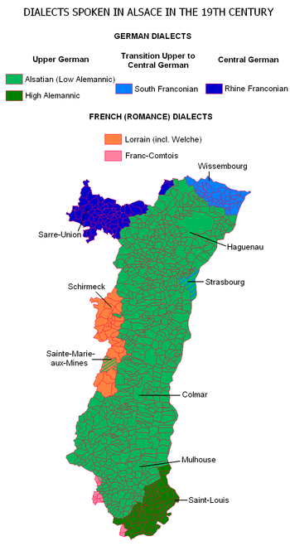
Spatial distribution of dialects in Alsace prior to the expansion of standard French in the 20th century
* The Flemish people during the 19th and early 20th centuries were under immense pressure to adopt French as their native language, but the attempt failed completely. In contrast to the Irish, the Flemish almost immediately organized a stiff resistance.

The Flemish people. The Wedding Dance by Pieter Brueghel the Younger, 1625
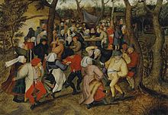
* Arabic was introduced around AD 700 in Egypt together with Islam. In the 17th century, some 900 years later, the original Egyptian language, Coptic, was still spoken despite severe persecution. A good Muslim had to speak Arab.
* The main language in Mexico is Spanish, but many of the local tribes still speak their original pre-Columbian language. Since 2003, 62 official languages are acknowleged in Mexico.
* The Basque language has survived since the pre-history. It is a non-Indo-European language. Basque is the language spoken by the Basque people who live in the Pyrenees in north-central Spain and the adjoining region of southwestern France, and by immigrant communities spread around the world, including the United States, Venezuela, Argentina, Mexico, and Colombia. It is believed to be a language isolate - a language with no known linguistic relatives.
Imposing a language seems to be no longer fashionable. Historians and linguists generally believe that Latin was introduced into Gaul around 50 BC, and evolved into French. This theory is probably not entirely correct.
Genetic studies reveal that the region around Paris is genetically distinct from e.g. Brittany (France). The whole south of Gaul (roughly south of the
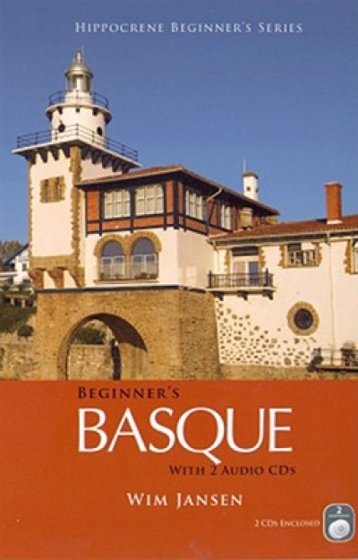

Loire) spoke Occitan before the Roman conquest. Occitan is so close to Latin that Latin itself can be considered to be nothing more but an Occitan dialect. It was most probably this Occitan which was introduced in the north of Gaul and not Latin itself. The local para-Brythonic language changed into 'northern-Occitan' and became as French the language of the vast majority in the North around AD 850. In northern Gaul, Occitan was not imposed, but widely accepted. The Gaulish aristocracy organized local schools for their children.
The Gallic Aristocracy and the Roman Imperial government in the fifth century A.D.
Minor, Charles Paul, Master of Arts, Texas Tech University, December (1976)
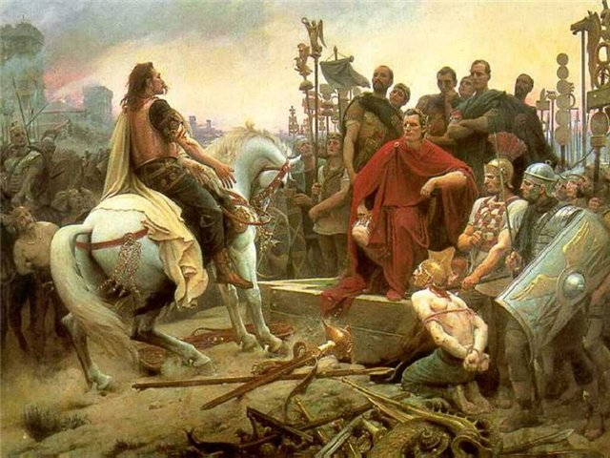
Schooling was not state subsidized until the end of the 19th century and had in most cases to be paid for privately. Less fortunate people had no access to schooling. The Gaulish aristocracy used the 'new' language early on to prove that they were educated, that their parents could afford schooling. In 486 AD, Clovis and his Franks conquered Gaul. Although the Franks spoke a Germanic language (proto-Flemish), they didn't manage to change the language in Gaul. The present language transition simply went on.
How can one explain that the Anglo-Saxons did succeed in changing the language in Britain? The transition needed at least some 900 years to become complete (54 BC - 850 AD). In the 5th century, Sidonius Appolinaris, a Christian missionary, complained in a letter to Rome about the fact that half the population in Gaul couldn't understand his (Occitan) sermons.
Sidonius Appolinaris, a Christian missionary
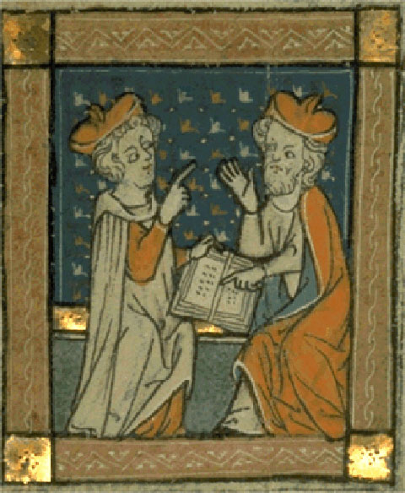
The original language of northern Gaul remains partly a mystery. A likely candidate is a Brythonic language, but remote from the language spoken in Armorica (Brittany) and West Britain, mixed with strong and early Occitan influences (maybe 50% of all words) and probably also Germanic words. Some words, now qualified as francique, could have been present in the language before the conquest of the Franks. The intimate relation of para-Brythonic with the southern Occitan language may explain why the language change happened apparently without resistance. The German words were suppressed in official texts, as those texts had to be written in the official Occitan dialect: Latin. Later, those Germanic words, already spread within the population simply came back. Forget the idea that French is derived from vulgar Latin. There was no such thing as vulgar Latin. There were only other Occitan dialects. So, the language gap was less wide than initially supposed.
The more an oppressed language is close to a new one, the faster a transition will happen. It is feasible to learn a close language without lessons. Native Dutch speakers can ‘pick up' German (or English) but not French. Since the 16th century official national languages, along with a fixed writing standard, were introduced in Europe and they had little trouble imposing themselves upon the local dialects. But when the gap is much bigger, like between French and German, or Welsh and English, things are less simple and much slower.
The period of 800 up to 1000 years seems to be the average time period of the transition from the original local language to the new imposed one. However, during the last 200 years, the general education (schooling) system proved to increase greatly the speed of language change. Some conditions though must come together to alter a language: people willing to impose their language upon the locals must have military supremacy, cultural supremacy and economic supremacy. The new language must have been sufficiently represented within or very near the targeted population during a long period. On top of that, the imposed language must provide added value. Without those combined conditions, local, well established populations will not change their language. (http://www.proto-english.org/l1.html)
Tasks.
Task 1. Arrange the words to form a sentence.
- they, peoples most, the center, believe, are, of the world.
- can, speak, we, also, a French language, about universe.
- within, universe, happens, everything, clearly, their own.
- not easy, entire, language, it is, to force, to change, populations, their, daily.
- long does to change, how, a language, need, completely?
- foreign to be learned, a, has, language.
- the majority, English, today, speaks, in daily life.
- almost, organized, the Flemish, immediately, stiff, a, resistance.
- good, to speak, good, muslim, a, had, Arab.
- a language, fashionable, imposing, seems, no longer, to be.
Task 2. Answer these questions in short simple sentences. Your answers must follow each other so that all your sentences will form a complete paragraph. Your paragraph will be a précis of the piece.
- What is true for well-established and dominant peoples in Europe?
- What is a narrow view of the world?
- Do many people worldwide speak English as a first language?
- Is it easy to force entire populations to change their daily language?
- Can a language change completely?
- Does the majority of Irish people speak English in daily life today?
- What language is mainly used in public life in France?
- Were the Flemish people during the 19th and early 20th centuries under immense pressure to adopt French as their native language?
- Why was Coptic still spoken in Egypt in the 17th century despite severe persecution?
- How many official languages are acknowledged in Mexico now?
- What is peculiar to the Basque language?
- What language did the whole south of Gaul speak before the Roman conquest?
- What did Sidonius Appolinaris complain about in a letter to Rome?
- What period seems to be the average time period of the transition from the original local language to the new imposed one?
- What are the combined condition local, well established populations can change their language?
Task 3. Explain the meaning of the words and phrases given below as they are used in the text:
peoples; valuable; second-class; well-established; to consider a language universe; imagining; a tradition; to escape; a narrow view; dominant peoples; a civilized language; worldwide; second language; a daily basis; to be cited; a cultural defense; the locals; daily life; public life; to be a serious advantage (for); to be allowed; to be encouraged; to be under immense pressure; a stiff resistance; to be introduced; severe persecution; a good Muslim; local tribes; to be acknowledged; to survive; an adjoining region; migrant communities language isolate; genetic studies; to reveal; to be widely accepted; to be state subsidized; to be paid for privately; a Christian missionary; sermons; to remain partly a mystery; without resistance; to be suppressed; feasible; to have little trouble; a gap; to increase greatly the speed of language change; to alter a language.
Task 4. Join the following sentences using the connecting words in brackets.
- Only smaller populations are more likely to escape from this rather narrow view of the world. Smaller populations have more tradition in foreign languages. (who).
- Dominant peoples gladly believe that others should change their language into a more civilized language. A more civilized language is of course their own one. (which).
- The number of people in the Gaeltacht region of Ireland has been variously cited as 70000 and 83000. They use the language as their daily mother tongue. (who).
- Studying (in) German is today allowed. Studying (in) German is today encouraged. (but).
- The Flemish people were under immense pressure to adopt French as their native language. This attempt failed completely. (but).
- The main language in Mexico is Spanish. Many of the local tribes still speak their original pre-Columbian language. (but).
- Occitan is close to Latin. Latin itself can be considered to be an Occitan dialect. (so…that).
- In northern Gaul, Occitan was not imposed. In northern Gaul, Occitan widely accepted. (but).
- Schooling was not state subsidized until the end of the 19th century. Schooling had in most cases to be paid for privately. (and).
- The Franks spoke a Germanic language (proto-Flemish). They didn't manage to change the language in Gaul. (although).
- The gap is much bigger, like between French and German, or Welsh and English. Things are less simple and much slower. (when).
Task 5. Divide the text into some logical parts and find the topical sentences of each part.
Task 6. What are Ukrainian equivalents of the following words and word combinations? Build the sentences with these words.
- second-class;
- well-established and dominant peoples;
- an English language universe;
- this rather narrow view of the world;
- a first (second) language;
- used on a daily basis;
- a language isolate;
- a daily language;
- a mother tongue;
- a cultural defence.
Task 7. Comment the following figures mentioned in the text:

- 800 years;
- 4,2 million residents;
- 350000;
- 155000 weekly;
- 585000;
- 460000;
- 30000;
- 350000;
- 70000 and 83000;
- 61 %;
- the 19th century (until 1870) and after 1918;
- 35.84%;
- the 19th and early 20th centuries;
- AD 700;
- the 17th century;
- some 900 years later;
- 62 official languages;
- 50 BC;
- AD 850;
- 486 AD;
- 54 BC - 850 AD;
- The 15th century;
- 800 up to 1000 years;
- the last 200 years.
Task 8. What are these people famous for?
- St. Gildas Badonicus (AD 500-570).
- King James I of England and VI of Scotland 1621.
- Clovis (c. 466 – 511).
- Sidonius Appolinaris (November 5 of an unknown year, perhaps 430 – August 489).
Task 9. Write a short essay “Some new theories of changing languages”. Search for information on the Internet.
Task 10. Take part in the on-line discussion :“Why does the language change? “

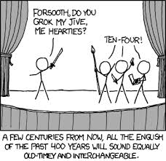

Text 3. Social pressure and promotion.
Normally, you would adopt a foreign language as your own if it provides a lot of added value. Suppose that all Britons spoke Brythonic before the coming of the Anglo-Saxons. What added value could the English language provide to them?
Brythonic Town
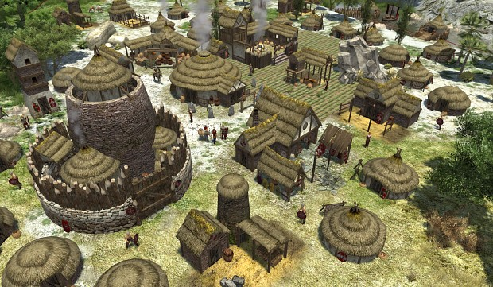
Roman society had been reasonably open. Roman law was applicable to every citizen. The nobility of one's family was not mandatory to access the highest ranks. Careers were very much possible.
Many Roman emperors came out of 'nowhere'. The British co-emperor Constantine III is such an example. He was qualified by his contemporaries as 'a man without nobility' ('sin nobilitas', or s.nob.). We have no idea from where he suddenly 'popped up'.
The knowledge of Latin was necessary if one wanted to make a career in the Roman administration, or in the Roman army or, later, in the Roman Church. Latin opened the doors to promotions. Speaking Latin in daily life meant that you had ambitions or that you had become a part of the upper-class.
St Laurence Church
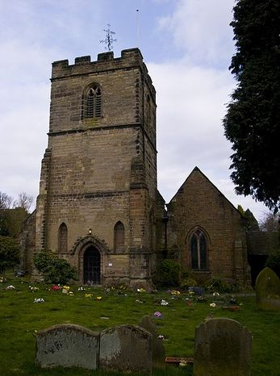
In contrast, Anglo-Saxon society was completely closed. Power and rank was and remained a family matter. Climbing the social ladder, the ascent to power, was very limited. Birth determined what rank you had, not the knowledge of a language, not even knowledge in general. Such a social system was typical for the aristocratic age.
Speaking English as a daily language provided therefore little advantage. Why would the British change their language? This would improve by no means their daily situation. On the contrary, speaking English as if it was your own language, could make other people suspicious that you were misrepresenting your actual rank in society.
After the fall of the Roman Empire, (private) schooling was no longer fashionable. Only the Catholic Church would continue to teach Latin. In addition, there are no indications that the Anglo-Saxons organized some sort of English language courses.
Lindisfarne Gospels
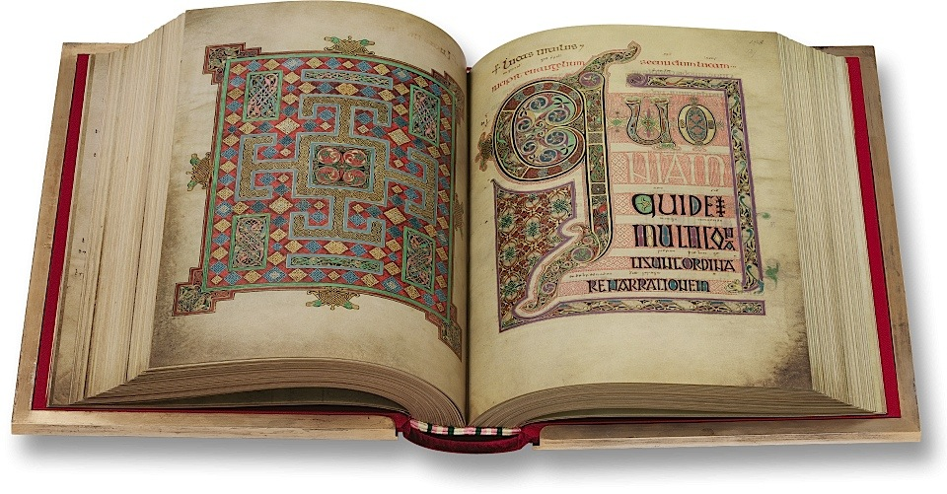

The legal system during the Roman Empire encouraged a language transition. The legal system during the Anglo-Saxon period discouraged a language transition. The statement that the Anglo-Saxons spread English because they were in power can therefore be dismissed. (http://www.proto-english.org/l2.html)
N.B. After Clovis had achieved his conquest of Gaul in 507 AD, Low Franconian, the ancestor of Flemish and Dutch, remained the language of the newly established Frankish aristocracy. The Gauls themselves continued their language transition to French. Texts, contemporary of Charlemagne, reveal that the Frankish aristocracy had the habit of sending their sons to Brabant (Belgium) "to learn proper Frankish". Low Franconian was the language of Charlemagne's court.
Chlodwig, Clovis (. 466 —511)
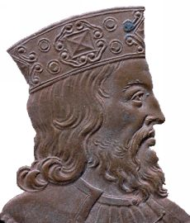
After the death of Charlemagne, the French aristocracy gradually adopted French as their native language. Low Franconian remained the aristocratic language in France for some 300 years (507 - 814 AD).
After his death (814 AD), Charlemagne is now regarded as the founding father of Europe.
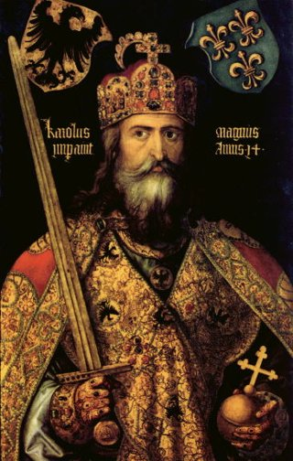
Tasks.
Task 1. Arrange the words to form a sentence.
- a lot of, would, as your own, it, added value, you, a foreign language, adopt, provides, if.
- open, had, Roman reasonably, society, been.
- Roman, 'nowhere', many, came out of, emperors.
- of, necessary, was, Latin, the knowledge.
- Anglo-Saxon, in contrast, closed, society, completely, was.
- a daily language, advantage, therefore, speaking, provided, little, English, as.
- English, spread, can, the statement, be dismissed, that, the Anglo-Saxons, therefore, because, they, in power, were.
Task 2. Answer these questions in short simple sentences. Your answers must follow each other so that all your sentences will form a complete paragraph. Your paragraph will be a précis of the piece.
- On what condition would you adopt a foreign language as your own?
- Had Roman society been reasonably open?
- Where did many Roman emperors come out of?
- Why was the knowledge of Latin necessary?
- What did speaking Latin in daily life mean?
- Was Anglo-Saxon society open?
- What a social system was typical for the aristocratic age?
- Did speaking English as a daily language provide any advantage?
Task 3. Explain the meaning of the words and phrases given below as they are used in the text:
to adopt a foreign language; to provide; added value; reasonably open; applicable; mandatory; to access the highest ranks; to come out of; to be qualified; to pop up; to make a career (in); open the doors to promotions; to become a part of the upper-class; completely closed; a family matter; the social ladder; the ascent to power; a social system; the aristocratic age; daily language; a daily situation; on the contrary; suspicious; to misrepresent; to be fashionable; to dismiss; to achieve; an ancestor; the newly established Frankish aristocracy; to reveal; to conquer; attending; compulsory; to pay special taxes; a language transition (from…to).
Task 4. Join the following sentences using the connecting words in brackets.
- You may adopt a foreign language as your own. A foreign language provides a lot of added value. (if).
- Roman law was applicable to every citizen. Careers were very much possible. Roman society had been reasonably open. (and, because).
- Speaking Latin in daily life meant that you had ambitions. Speaking Latin in daily life meant that you had become a part of the upper-class. (or).
- Power and rank in Anglo-Saxon society was a family matter. Power and rank in Anglo-Saxon society remained a family matter. (and).
- The legal system during the Roman Empire encouraged a language transition. The legal system during the Anglo-Saxon period discouraged a language transition. (but).
Task 5. Read the text and try answer the questions below. You may need some additional information.
- What do you know about Brythonic languages?
- What opportunities did the Roman law provide for people in Britain?
- What was the value of Latin and Low Franconian at that time?
- What kind of social system was typical for the aristocratic age?
Task 6. Divide the text into some logical parts and entitle them.
Task 7. What are Ukrainian equivalents of the following words and word combinations? Build the sentences with these words.
- to adopt a foreign language;
- added value;
- mandatory;
- to access the highest ranks;
- nobility;
- daily life;
- a family matter;
- to provided advantage;
- to misrepresent;
- a language transition;
- to encourage/to disencourage.
Task 8. What are these people famous for?
- Charlemagne (2 April 742 – 28 January 814).
- Constantine III (Flavius Claudius Constantinus) (died 411 by 18 September).
Task 9. Comment on the last paragraph of the main text.
Task 10. Can you explain now why the British changed their language?

Text 4. The supposedly closest languages are not the closest.
Part 1.
The Saxons came from Sachsen (Saxonia) in Germany. This region is ‘axed’ between the rivers Weser and Elbe, stretching from the North Sea to Tchechia, hence its name. They also used frequently a short sword called 'sax' . The word for this weapon could be derived from the region and not the other way around.
Autumn in Saxonia
The Angles came from the south of Denmark, a region called today Schleswig Holstein. The name is derived from 'ang, eng' which means 'narrow' and refers to the south of the Danish peninsula. In Britain, the name Angles was used for all coastal inhabitants, from Friesland up to Denmark. According to official history the local language or dialect of those regions should be the closest language to English. Nevertheless, it’s not, although multiple attempts were made to prove the link.
Fact is that the very first Old English texts show no sign of a compromise language. The name 'Anglo-Saxon' itself predicts the emergence of a compromise, go-between language. But no. The texts are from the very beginning, very early on, different from each other, although it is not difficult to demonstrate the attempts of the monks to create one single written language, with Latin as their great example in mind.
Schleswig-Holstein.
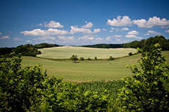
Part 2. Dutch vs Western Flemish
Officially, the closest language to (official) English is (official) Dutch. General Dutch is a compromise language between several distinct dialects. It is a recent standard (17th century).
Fries is a part of the Dutch language group, but considered a separate language. The Frisian language is announced to be the closest language to English. There is however another candidate to that: Western Flemish. Friesland borders Germany and originally stretched beyond that border. The attempt to link the Fries language to English was clearly induced by the close location of Friesland to Sachsen and the fact that some Fries took part in the Anglo-Saxon migration. In other words: it fits the official theory. Insidious studies tried to prove a close link between the Fries language and English. The Fries people never were genuine Germans, and are proud of that. It is unlikely that only the Fries language generated English.
(Former) area of Frisian settlement, today’s areas of Frisian language.
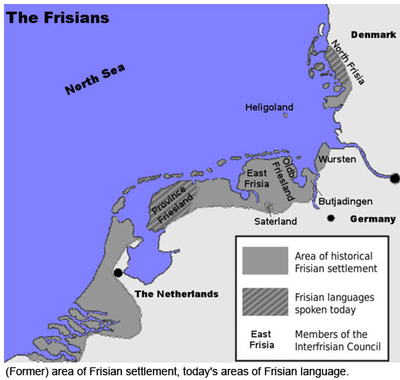
The Anglo-Saxons dominated England, nobody speaks or spoke about Friso-Saxons or Anglo-Fries. This indicates that the Fries alone were not numerous enough to impose their name. They must be considered minority amongst the Anglo-Saxons. Fries is not easy to learn, not for the Dutch, not for Germans. It's an unlikely candidate for a compromise language.
In fact, another language is also very close to English: western Flemish. This language is still locally spoken today (Bruges, the Belgian coast, Ieper, Kortrijk). This language is considered to be a dialect of general Dutch and is an important fraction of the Dutch language group. More and more linguists consider it a separate language, just like Fries. It was once more widely spread. The coast of Flanders (Belgium) is also the geographically the closest to the English southeast coast. Nearby Calais (France), and the region around it, was until the late Middle Ages Flemish territory.
The town of Ypres is located in the Flemish Province of West Flande.
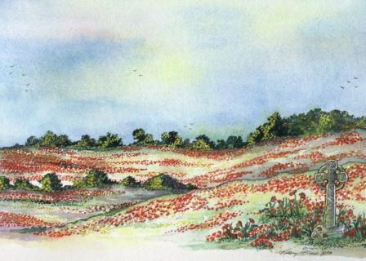
The relation with English can be illustrated as follows: words like thin, pit, hill are translated in general Dutch as dun, put, heuvel but in western Flemish as dinne, pit, hille (e.g. the place-name Stalhille). It is no coincidence that both languages, Fries and western Flemish are close to English as the three have the most Ingweoon characteristics. It is clear that the name Ingweoon was chosen as was supposed that English was imported from northern-Germany. The set of tribes corresponds more or less with the 'tribes' that formed the Anglo-Saxons. Ingweoon was a name for a set of northern German tribes (a subdivision of Germany) and was reported by the Roman historian Tacitus. Fries and Western Flemish are separated by some 300 km. But it is known that once upon a time very similar dialects were spoken along the Dutch coast, linking western Flemish and Fries. Ingweoon is also called coastal German. So, it's no coincidence that English is also called Ingweoon.
Explaining this by stating that the language 'simply' was imported from northern Germany is not sufficient. The very presence of Western Flemish near the narrowest part of the English channel indicates another possibility. (http://www.proto-english.org/l6.html)
Tasks.
Task 1. Arrange the words to form a sentence.
- from ,came ,The Saxons, Germany, Sachsen (Saxonia), in.
- the language or of those language, according to, local, should, dialect, official history, be, to English, the closest, regions.
- the link, multiple were made, attempts, to prove.
- predicts, the name itself, of a compromise, language, the emergence.
- is, compromise, several, General Dutch, distinct, a language, dialects, between.
- the closest, announced, is, to be, the Frisian language, language, English, to.
- were, Germans, the Fries, people, genuine, never.
- Must, the Fries, the Anglo-Saxons, minority, be considered, amongst.
- is, western Flemish, spoken, locally, still, today.
- general Dutch, to be, this language, a dialect of, is considered.
Task 2. Answer these questions in short simple sentences. Your answers must follow each other so that all your sentences will form a complete paragraph. Your paragraph will be a précis of the piece.
- Where did Saxons come from?
- What is the origin of their name?
- Where did Angles come from?
- What is their name derived from?
- Do the very first Old English texts show any sign of a compromise language?
- What does the name 'Anglo-Saxon' itself predict?
- Who was trying to create one single written language, with Latin as their great example in mind.
- Is General Dutch a compromise language between several distinct dialects?
- What group is Fries a part of?
- Were the Fries people ever genuine Germans?
- What language is also very close to English?
- What dialect is western Flemish considered to be?
- What region was until the late Middle Ages Flemish territory?
- . Was Ingweoon a name for a set of northern German tribes and was it reported by the Roman historian Tacitus?
Task 3. Explain the meaning of the words and phrases given below as they are used in the text:
stretching; frequently; a short sword; a weapon; to be derived from; a region; to refer to; coastal inhabitants; official history; the local language or dialect multiple attempts; to prove the link; to show a sign of; a compromise language; to predict; the emergence of; a go-between language; to demonstrate the attempts; to create one single written language; a recent standard; a separate language; to be announced; to be induced; it fits the official theory; to dominate; to indicate; to impose; to be considered minority; to be widely spread.
Task 4. Join the following sentences using the connecting words in brackets.
- The texts are from the very beginning different from each other. It is not difficult to demonstrate the attempts of the monks to create one single written language. (although).
- Fries is a part of the Dutch language group. It is considered a separate language. (but).
- The Frisian language is announced to be the closest language to English. There is another candidate to that: Western Flemish. (however)
- Friesland borders Germany. It originally stretched beyond that border. (and).
- The Fries people never were genuine Germans. They are proud of that. (and).
- The Fries alone were not numerous enough to impose their name. They must be considered minority amongst the Anglo-Saxons. (so).
- Fries is not easy to learn. The Dutch is not easy to learn. (neither…nor).
- Western Flemish is considered to be a dialect of general Dutch. It is an important fraction of the Dutch language group. (and).
- Ingweoon was a name for a set of northern German tribes. It was reported by the Roman historian Tacitus. (as).
- Stating that the language 'simply' was imported from northern Germany is not sufficient. The very presence of Western Flemish near the narrowest part of the English channel indicates another possibility. (because).
Task 5. Re-read the text (Part 1).Say, whether the following statements express facts or ideas:
- The Saxons came from Sachsen (Saxonia) in Germany.
- The Angles came from the south of Denmark.
- The very first Old English texts show no sign of a compromise language.
- The name 'Anglo-Saxon' itself predicts the emergence of a compromise, go-between language.
- It is not difficult to demonstrate the attempts of the monks to create one single written language.
(A fact is a thing KNOWN to be true or to have really happened. Facts can be ascertained through documentation or experimentation. An idea is just a thought or an opinion or even a suggestion. It is possible that an idea could become a fact. Most facts are originally determined by someone having an idea and proving it to be true. /http://wiki.answers.com/Q/What_is_the_difference_between_facts_and_ideas)
Task 6. Re-read the text (Part 2) and answer the question:
- What languages are considered to be the closest languages to English?
- What was the attempt to link the Fries language to English induced by?
- Were the Fries people genuine Germans?
- Is it is likely that only the Fries language generated English?
- Is Western Flemish spoken today?
- What group of languages does it belong to?
- What kind of characteristics do Fries, western Flemish and English have?
- What fact was reported by the Roman historian Tacitus?
Task 7. Divide Part 2 into some logical parts and entitle them.
Task 8. Find the key words of the story.
Task 9. Build up sentences, using the following words and word combinations:
- the Saxons;
- a region;
- to stretch;
- to derive;
- the Angles;
- to refer to;
- coastal inhabitants;
- official history;
- the local language or dialect;
- to prove the link.
- a compromise, go-between language;
- to create one single written language.
Task10. Write a short essay on one of the following topics. Search for additional information on the Internet :
- The story of the Saxons.
- The story of the Angles.
- The story of the Fries.
- The story of the Ingweoons.
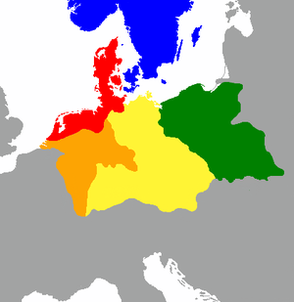
The distribution of the primary Germanic dialect groups in Europe in around AD 1:

North Germanic
North Sea Germanic, or Ingvaeonic
Weser-Rhine Germanic, or Istvaeonic
Elbe Germanic, or Irminonic
East Germanic

Precis writing.

Text 1. Language borders in Europe
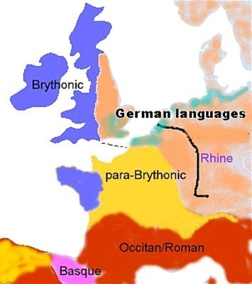
The languages around 50 BC
Tasks.
- Analyze each paragraph of the text from the point of the logical division.
- Divide the text into logical units. Join several paragraphs if necessary.
- Suggest a suitable title for each paragraph so that you have a detailed plan of the text.
- Express the main idea of each paragraph in a single sentence in English.
- Develop the titles into topic sentences. Join the topic sentences into entity. The précis should not exceed one third of the passage.
- Divide the text into an introduction, principal part and conclusion. Make regroupings if necessary.
- Write a précis of the article. It should not exceed one third of the article.
- Translate the précis into Ukrainian.
Each language was subdivided into strong dialects. Brythonic is proto-Welsh. Para-Brythonic is wrongly qualified as a 'Gallic' language. This language was based upon Brythonic but had been intensively influenced by Occitan and German. A bit like modern English is based upon a Germanic language, but 60% of all its words are foreign, mostly of French origin. People who spoke para-Brythonic could not understand Brythonic.
In reality para-Brythonic is a complete mystery. The existence of para-Brythonic is an assumption. We have no texts in this language. Para-Brythonic will change into 'northern Occitan' and later into French. The supposition of the existence of Brythonic and para-Brythonic is partially based upon genetic findings. Both people differ greatly in their genetic markers (Oppenheimer).
The Occitan or Roman language is the real 'Gallic' language. The qualification 'Roman' is misleading as it suggests that the Romans imported the language. That's not the case. Latin was initially just one of the Occitan dialects. The name 'Gallic' referred to the Occitan dialects in northern Italy and southern France.
At the time of Julius Caesar, the Brythonic-Germanic language border was situated to the south of modern Belgium, roughly in the neighbourhood of the Somme river.
But the language border did not end at the Channel. In fact, as we continue the line straight over the Channel we find ourselves somewhere around Bristol. From there, it goes almost straight north to Scotland. There is an overwhelming amount of proof that Brythonic was the language of the west, but how sure are we that the east of Britain spoke a similar language? The most logical answer is that those eastern Britons spoke a language, long before the Romans came, that resembled most to Flemish (=coastal German). In other words: the language simply continued over the Channel. Eastern Britons spoke a genuine and original Germanic language.
Gaius Julius Caesar, a determined leader (July 100 BC – 15 March 44 BC)
The main problem is to know where English stopped and Brythonic began. We know that that language border moved slowly and continuously from east to west. But we realize that it will be very difficult to determine where the language border was at one given time. But there could be exceptions.
We think that for instance, the language border was situated a bit to the east of Stonehenge around 2500 BC. We think that Stonehenge was build to send a strong (politico-religious) message to the nearing proto-English enemy. "Stay there! Look what we are capable of doing!" But proto-English continued to move west and that around 1900 BC the language border had passed over Stonehenge. The whole costly exercise had failed. The local language and culture, which had been responsible for the building of the monument, vanished under pressure from the east.

Stonehenge
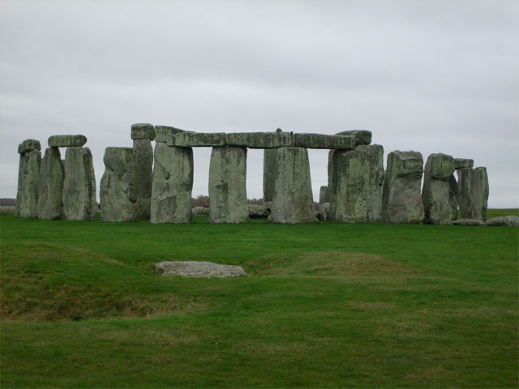
Written proto-English is called Old English. There is a major difference between Old English and Middle English (medieval English). What happened? It is simple: old English was a language that was maintained as an intellectual language by the contemporary upper-class: aristocracy and clergy, more specifically: monks. They translated new foreign concepts in new English compound words.
To give a fictitious example: the French invented the concept of the dictionary and called it: dictionnaire. The English monks took over the idea but not the word itself. They agreed that it would be 'wordbook'. Sadly, this a fictional example, because the word dictionary exists in English and not 'wordbook'. Compare with Dutch woordenboek and German Worterbuch. Had the dictionary been invented before the Middle Ages, then the chance was not negligible that the English word would be wordbook.
During the Middle Ages, not English but French was the dominant language in England. The reason is the conquest by William the conqueror and the replacement of the old English aristocracy by a Norman one. For 400 years, French was spoken in the House of Lords and not English. It is only because of the war with France that French became unpopular in the fifteen century and that English was gradually restored as a native language. Sadly, a lot had happened in Europe and England in the mean time and a lot of new notions had emerged. The English intelligentsia failed to defend the English language for 4 centuries and all intellectual words had become French. Example: I count six words of French origin in the previous sentence and three in this one. The result is a mixed language where almost 50% of all words are of foreign, mostly French, origin.
William the Conqueror (c. 1028[2] – 9 September 1087)
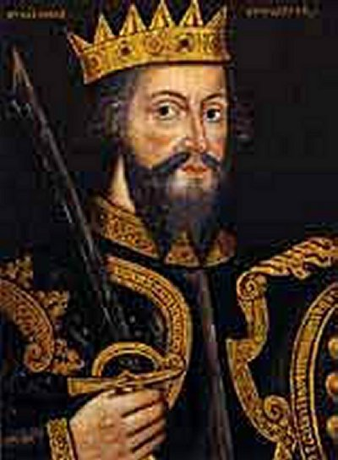
Without the conquest by the Normans, the English language would have had a completely different vocabulary. For instance the word vocabulary would be 'wordscat', where 'scat' is an old Germanic word for treasure.
Virtually the same phenomenon could be observed in Brussels during the first half of the 20th century. Native Flemish of the city, who had no chance to study, used French words when they needed more 'intelligent' words. For instance, they used the word 'dictionnaire' instead of the Dutch 'woordenboek'. The reason is that most of the intelligentsia and upper-class in Brussels spoke French at the time. Flemish (Dutch) was considered to be a lower-class language or even a non-language. That francophone attitude toward Dutch has changed a lot since Flanders has regained its ancestral wealth. The opposite is now going on. French speaking youth, who study at a Flemish school, use Dutch words in their French language when they need 'intelligent' words. (http://www.proto-english.org/l7.html)

Text 2. Dialects and imported languages.
Tasks.
- Analyze each paragraph of the text from the point of the logical division.
- Divide the text into logical units. Join several paragraphs if necessary.
- Suggest a suitable title for each paragraph so that you have a detailed plan of the text.
- Express the main idea of each paragraph in a single sentence in English.
- Develop the titles into topic sentences. Join the topic sentences into entity. The précis should not exceed one third of the passage.
- Divide the text into an introduction, principal part and conclusion. Make regroupings if necessary.
- Write a précis of the article. It should not exceed one third of the article.
- Translate the précis into Ukrainian.

Imported languages.
The English language, as used today in Australia, can be traced to its earliest colonisers. It is known that the British stuffed the colony with criminals. This lower class English is still very much present in the local language. Australians use words like ‘mate’ which are shunned by the (upper-class) British.
Similar is the distinction between Belgian French and French French. Officially there is no distinction, but the reality is different. Belgian French has a slightly divergent pronunciation and uses some expressions they learned from the Flemish. These characteristics can be found in the respective former African colonies. Example given: the black Africans in the DRC (Democratic Republic of Congo – former Belgian Congo) still speak French with a Belgian accent. My point is: when a language is imported, it can be traced to the people who imported it.
This means that, if one supposes that English was imported by Angles, Saxons, Fries and Jutes, that those respective languages should be traceable in England. Some old English texts should resemble Old Saxon, Old Fries, Old Norse (= also Old Danish), etc. One can suppose for instance that the oldest texts from Sussex (= South Saxonia) should bear a resemblance to continental Old Saxon. Perhaps one can state that the names of those old kingdoms do not necessarily reflect the majority of its conquerors. But at least, some old English texts should have some resemblance with some old texts of some regions in northern Germany. At least, that was supposed. That was to be expected. But is it?
In fact, Hans Frede Nielsen wrote in 1979 a paper "The Old English Dialects and the Continental Germanic Languages" in which he tried to demonstrate the existence of linguistic links between the old continental Germanic languages and their local British counterparts. Example: is the Old English variant of Wessex (West-Saxonia in England) really closely related to Saxonia in Germany?
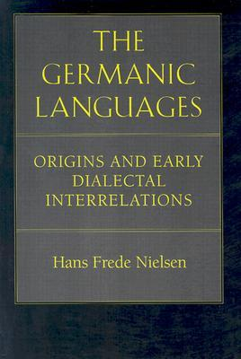
After an assiduous study Nielsen should have discovered some strong indications in a number of language details, called innovations. But to his great surprise Nielsen came to exactly the opposite conclusion: no link between regional Germanic variants in Britain and their continental homologues could be demonstrated, au contraire. He was unable to show for example that Wessex was populated by Saxons or that east Anglia was by Angles and so on. He found a complete chaos. For instance, Northumbria is reputed to be conquered by Angles, but local language innovations do not refer to north Germany (where the Angles came from) but instead refer to Old High German (south Germany) and Old Flemish. No logic whatsoever could be found. The Old English dialect behaved fully independently from the Continent. For me, this all points in one direction only: English evolved independently way before the Anglo-Saxons arrived. Sadly, this highly important paper was superbly ignored. Actually, Nielsen himself was sorry.
Dialects: general considerations
The study of dialects is a relative recent science. It’s only the last 50 years or so that it is taken seriously. Before that time, dialects were ‘not considered worth to be studied’.
As this science is so young there is little consensus even about the definition of what a dialect is, or when a local tongue can be considered as a dialect. The boundary between a dialect and another language is also not clearly defined.
Some linguists consider the major Scandinavian languages like Norwegian, Swedish and Danish as dialects of each other. Officially they are distinct languages. The distinction has more to do with politics than with objective criteria.
South-Afrikaans was considered until 1926 to be a form of Dutch. Since then, it is supposed to be a derived, but distinct language. South-Afrikaans speaking people can understand easily official Dutch, and Dutchmen need little time to adapt to the South-African language.
Afrikaans Language Monument
Is American English a dialect of Standard English? Most scholars believe that there is little to distinct both tongues. A softer type of dialect is ‘variant’, so American English can be considered as a variant of English. One of the most used criteria is whether both people do understand each other without great difficulties. The fact is that Americans have no trouble at all in understanding British English. On the other hand is Western-Flemish regarded as a dialect of general Dutch. But people from Holland, for instance Amsterdam, can by no means understand what the Western-Flemish are saying to each other. They almost would understand general German better.
How much is Western-Flemish a dialect and not a separate language? Little is known about the mechanism of the emergence of dialects. Most scholars will however agree that 2 conditions are important: isolation and time. South-Afrikaans is a good example: it is relatively old (± 400 years) and was pretty isolated. But as we saw, the distinction with official Dutch is smaller than with some sub languages of Dutch like Fries or Western-Flemish. Time is therefore the most important condition. The more dialects there are within a language group, the older this group is. For Dutch with its official 29 dialects, this means: very old, some 6000 years at least. English is most probably not much younger.
By comparison, France has much less dialects. It is true that French is a relative young language as it has originated from 'northern Occitan-Romance' (mixed with its official dialect: Latin). We can state that French is ‘only’ some 1400 years old.
Dialects from across Great Britain.
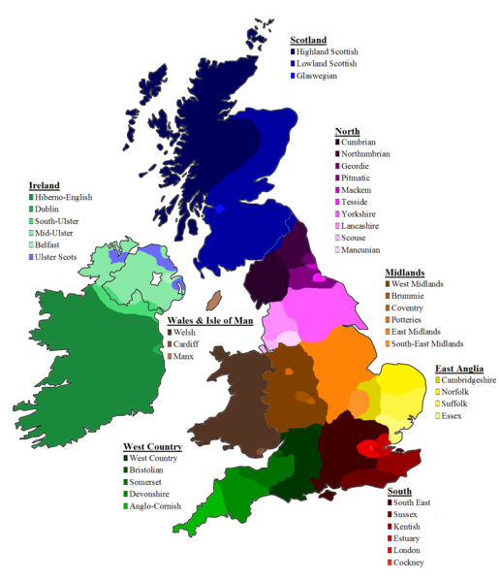
We should also not confuse a dialect with a poor knowledge of the language. People who do not use English as their primary language have sometimes an accent, make errors, but this cannot be judged as a dialect. (http://www.proto-english.org/l12.html)

Text 3. How many Anglo-Saxons came over?
Tasks.
- Analyze each paragraph of the text from the point of the logical division.
- Divide the text into logical units. Join several paragraphs if necessary.
- Suggest a suitable title for each paragraph so that you have a detailed plan of the text.
- Express the main idea of each paragraph in a single sentence in English.
- Develop the titles into topic sentences. Join the topic sentences into entity. The précis should not exceed one third of the passage.
- Divide the text into an introduction, principal part and conclusion. Make regroupings if necessary.
- Write a précis of the article. It should not exceed one third of the article.
- Translate the précis into Ukrainian.
The assumption must be that consecutive Anglo-Saxon generations had plenty of time to integrate themselves into the local population. As mentioned, they came initially as 'mercenaries', in fact: professional soldiers, so it would be logical that they learned quickly the language of their masters. Young soldiers also are likely to marry local girls. Later, after allegedly taking over power, it would be commonsense that the knowledge of the local language would help them to maintain that power.
As the new arrivals represented less than 0,50% of the population, they had no time to teach their language to the 99.50% others. More over, there were little or no schools. Imposing their language risked also to upset the local population. Trouble with a local population is always the last thing a professional soldier wants.
As this map demonstrate the Angles, Saxons, & Jutes settled only the south EAST corner of Scotland and also never settled in Wales or Cornwall
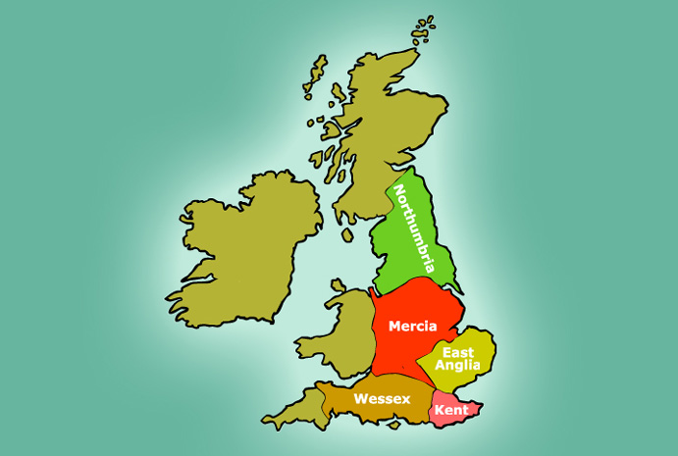
You don't need to know the local language when you conquer a country. Maintaining power locally however requires a good knowledge of the local language. It's all about gathering information, detecting a possible insurgence.
Rome had the standard policy to relay heavily upon the local authorities to maintain its power locally. Those authorities were left in place after the conquest and if necessary, their power was even enforced. In return, Rome demanded from the local upper-class absolute loyalty. If a rebellion occurred, it were always the leaders of that rebellion who were severely punished. This policy allowed the Romans to maintain very little occupation forces. The group of people that had to be watched was indeed very small. The Romans never replaced the local upper-class by their own. Suppose that the Anglo-Saxons would have replaced the British upper-class. This would have cost them an immense military effort. In fact, a bigger effort than the Romans themselves were able to perform. Let alone that the Anglo-Saxons were able to impose their language on top of that.
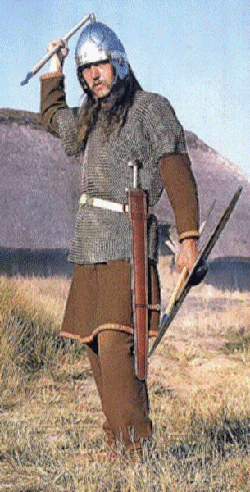
Most Anglo-Saxons must have been young and eager warriors, so one can imagine the impact upon the local girls. The Roman historian Tacitus already mentioned in 98 AD (“Germania”) as a curiosity, that the Germans had a great respect for their women. Logically, the Anglo-Saxons would have sought some allies locally, and the local women and their family (soon to be in law) must have been the obvious choice. This means that it would be the alleged invaders who had to learn the local language. The eventual emerging new families were in reality very (east-)British all but in name.
The Anglo-Saxons needed quite some time to conquer the whole of (modern) England. More than 150 years. This contrasts with the swift conquests by the Romans earlier, and by the Normans later. The reality was that the Anglo-Saxons themselves did not conquer England and certainly not Welsh West England. Their British lords (=rich landowners) had this ambition. Those lords wanted to consolidate their authority at home first, and then start an expansion to the Welsh west with the help of Anglo-Saxons. As soon as the lords had integrated some high ranking Anglo-Saxon officers within their families, they took over the label "Anglo-Saxon", "Saxon", "Angles" or similar.
The limited quantity of Anglo-Saxons soldiers is the main reason for the very slow expansion towards West England. One can estimate that at no given moment the number of native, German, Anglo-Saxon warriors exceeded 3000 men. Maintaining power with such a small quantity of warriors is not easy. Luckily, England was much divided. This division was the result of the increased power of the local lords thanks to the hiring of Anglo-Saxon soldiers. The 'Anglo-Saxon' kingdoms could only expand their power after the local mentality had changed in favour of the 'German' mentality (= duty, loyalty, respect for authority).
The 'Anglo-Saxon' kingdoms
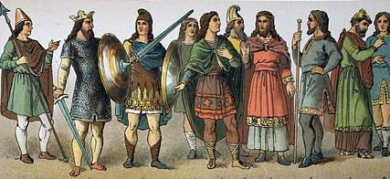
The Anglo-Saxons never had the ambition to impose their language upon the local population. This was not their task. The gain was very limited, the risk to upset the locals great. Their task was maintain 'law and order', read : to uphold the authority and power of their British masters. The Anglo-Saxons became British housecarls. (http://www.proto-english.org/a2.html)

Text 4. Why Anglo-Saxons?
Tasks.
- Analyze each paragraph of the text from the point of the logical division.
- Divide the text into logical units. Join several paragraphs if necessary.
- Suggest a suitable title for each paragraph so that you have a detailed plan of the text.
- Express the main idea of each paragraph in a single sentence in English.
- Develop the titles into topic sentences. Join the topic sentences into entity. The précis should not exceed one third of the passage.
- Divide the text into an introduction, principal part and conclusion. Make regroupings if necessary.
- Write a précis of the article. It should not exceed one third of the article.
- Translate the précis into Ukrainian.
The question may be surprising but the answer is not obvious. Most migrating tribes at the end of the Roman Empire wanted to go south where the climate is of course much warmer. However there are two known exceptions to that general movement: the Franks, and the Anglo-Saxons. The migration of the Anglo-Saxons to Britain is understandable because they were initially invited as, what is called by many authors, 'mercenaries'. The word mercenary is however misleading: normally mercenaries are not a part of the legal army. Why would Britain hire 'mercenaries' while they could have built with the same money a regular British army?
This raises an important question. Around the beginning of the 5th century the English coast was raided by Picts, Irish and Scandinavian people. It is likely that those people were desperate for food and income. Picts for instance, always had a good reputation as soldiers. The inhabitants of modern Scotland were and are tough men. Moreover, they spoke a Brythonic language. Why were they not hired as soldiers?
The English coast was raided by Picts
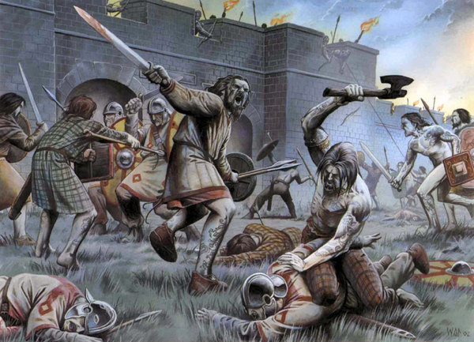
The (Anglo-)Saxons were described by Gildas as ‘foederatii’ (federated troops). Historians have much debated about the exact meaning of the word. During the late Empire this word indicated all 'auxiliary' troops of the late-Roman army, in contrast to the dwindling numbers of 'classic' legionnaires. At the end of the Empire, they outnumbered the legionnaires, supposedly the bulk of the army. They came mostly from regions at the borders of the Roman Empire, which had obtained a great tax autonomy in exchange for a promise to provide troops at the service of the emperor. An important part of those cohorts was cavalry. Cavalry can move fast and can better tackle a dispersed enemy (raiders). The Empire increasingly lacked the financial resources to pay for powerful but slow legions. The word foederatii let some authors to put forward the idea that the Anglo-Saxons were in the beginning a part of the regular Roman army. They were supposed to be members of German auxiliary cohorts, recruited outside the Empire, and stationed in Britain by the Romans themselves. The underlying idea is that they later betrayed their masters. Can't one expect anything from those bloody Germans? This 'scientific' interpretation was clearly influenced by the 20th century wars against Germany.
Cavalry can move fast and can better tackle a dispersed enemy
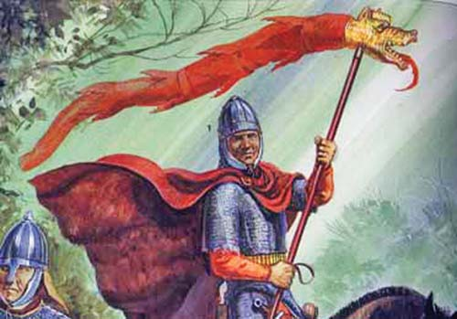
It is true that many of the few remaining Roman legions those days were stuffed with Germans. But those Germans were mostly Germano-Romans, Roman citizens who were born within the Empire, west of the Rhine and south of the Danube. An estimated 4 million German speakers lived inside the Empire. This simple fact has been overlooked. Those Germano-Romans had become very loyal citizens and an ideal recruitment base. The fact that they were mentioned as Germans simply means that the Romans had become more and more aware of the many different populations within the Empire, and that they acknowledged them, respected them, as such. An author like Zosimus (5th century) mentions conspicuously often the ethnic background of various Roman citizens. Gildas simply used the word in its classic meaning: legal troops, but not legionnaires. They were not irregular mercenaries.
St. Zosimus was born in Italy and was elected as Pope in the year 417.
He reigned until the year 418
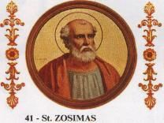

The reported series of events during the 5th century contradicts the idea that the Anglo-Saxons originated from the regular Roman army.
Who were the best soldiers of the Empire? The Roman legionnaires without doubt, even at the very end of the empire. They were well trained, disciplined, and loyal to Rome. Former legionnaires would have been ideal to build a new army. Most legionnaires in Western Europe were Gaulish, Spanish or German in origin. And a surprising number of Britons. If the gauls spoke the same Brythonic language as the Britons (as conventional history asserts) they would have been a natural choice as soldiers. So why were rude north Germans chosen instead? Why not the closer Franks? Why not the Britons themselves?
We also know that at least one lord in the east married a Frankish ‘princess’. They must have tried to obtain help from the Franks. As Franks were Flemish or northern Belgians, they would have been a close by, obvious choice. The Franks had ‘freed’ themselves earlier from the Roman Empire (352), and became officially ‘federated’ to the Empire. The main agreement was that they would stop all incursions of German ‘tribes’ passing through their country (Greater Flanders) who were heading for the southern parts of the Empire. The Franks were successful in doing so. They maintained for the purpose a sort of militia, not a Roman style professional army. They helped fighting Atilla (452) and later supported the northern Gallo-Roman governor in his struggle against German tribes. It is however likely that they did so for their own sake also and that they were paid for the service. They were relatively rich, for they later (485 - Clovis) had the means to conquer Gaul. (http://www.proto-english.org/a3.html)
This is a miniature of Attila the Hun, aka the Scourge of God (406-553), meeting Pope Leo the Great (p. 440-461) in 452. The picture is from the Chronicon Pictum, a medieval illustrated chronicle dating from fourteenth-century Hungary.
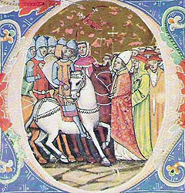

Text 5. The events before the 5th century
Tasks.
- Analyze each paragraph of the text from the point of the logical division.
- Divide the text into logical units. Join several paragraphs if necessary.
- Suggest a suitable title for each paragraph so that you have a detailed plan of the text.
- Express the main idea of each paragraph in a single sentence in English.
- Develop the titles into topic sentences. Join the topic sentences into entity. The précis should not exceed one third of the passage.
- Divide the text into an introduction, principal part and conclusion. Make regroupings if necessary.
- Write a précis of the article. It should not exceed one third of the article.
- Translate the précis into Ukrainian.
Constantine the Great (27 February c. 272 – 22 May 337), 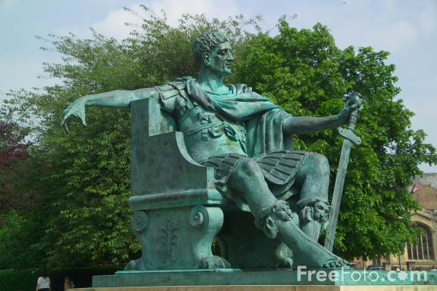
Constantine the Great was proclaimed emperor in York in AD 305. He managed to re-unite the whole Empire. His brilliant career must have inspired the British upper class. During the reign of their emperor the British economy enjoyed a strong revival. At his death, the two sections of the western half of the Empire went to two of his three sons. One section included Hispania, Gaul, Belgium and Britain, was ruled by Constantinus II in AD 337 and his brother Constans was made emperor of Italy and North-Africa (see antique map). The third son obtained the eastern Empire with Byzantium as its capital.
Maximus Clemens Magnu (ca. 335 – August 28, 388)
In AD 383 Maximus Clemens Magnus, a Spaniard related to a Welsh family, was proclaimed emperor by his troops over the Gaul Preafectura, while serving with the army in Britain. Later legend made him King of the Britons; he handed the 'throne' over to Caradocus when he went to Gaul to pursue his imperial ambitions.
Maximus went out to meet his main opponent, Gratianus, whom he defeated near Paris. Gratianus, after fleeing, was killed at Lyons on August 25, 383. Soon after, Maximus managed to force Valentinian II out of Rome after which Valentian fled to Theodosius I, the Eastern Roman Emperor. Maximus made his capital at Augusta Treverorum (Trier) near the west shore of the Rhine. He became a popular emperor, although also a stern persecutor of heretics.
Theodosius I and Valentinian II campaigned against Magnus Maximus in July-August 388 AD. Maximus was defeated in the Battle of the Save, near Emona, and retreated to Aquileia. Andragathius, magister equitum (general) of Maximus and killer of Gratian, was defeated near Siscia, his brother Marcellinus again at Poetovio. Maximus surrendered in Aquileia and although he pleaded for mercy, he was executed. However, his wife and two daughters (one was called Sevira) were spared. Maximus' son, Victor, was defeated and executed by Valentinian's magister peditum Arbogast in the fall of the same year.
In Brittany (Gaul) Maximus had appointed one of his loyal friends Conan as 'administrator'. Conan’s successors would bear the title of king. This appointment suggests that many of the high-ranking officers in Maximus' army were of Welsh origin, and that the Welsh had supported his ambition financially. The link between Britanny and the Welsh is known. The tradition in the Roman army was that many high-ranking officers were senators. They often contributed to the finances. After the demise of Maximus, Roman rule slowly returned in Britain. The east of Britain was upset by the waste of money Maximus’ wars had cost. Rome sent some legions. However, the legions could not stay and urged the British to defend themselves (Gildas). In other words: find the necessary money and create a local militia. Britain had to organize a local defense system. Gildas mentions that the British built a local defense force, and that it had some success. But instead of pursuing, the money was wasted on luxury instead of defence.
Flavius Stilicho (occasionally written as Stilico) (ca. 359–408)
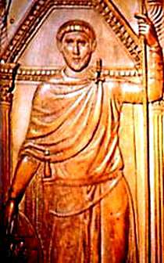
In 397 a Roman commander, Stilicho, came to Britain to restore law and order. He is said to have successfully fought Picts, Irish and Saxon raiders. Gildas wrote: "A legion is forthwith prepared, with no remembrance of past evil [= Maximus Magnus, the usurper], and fully equipped. Having crossed over the sea in ships to Britain, it came into close engagement with the oppressive enemies; it killed a great number of them and drove all over the borders, and freed the humiliated inhabitants from so fierce a violence and threatening bondage." Gildas (not naming Stilicho) also mentions (earlier) a famine which suggests that the real reason why Stilicho intervened could be a local rebellion. This tells us something about the quality of the local British defenses. This time, Rome maintained legions in the unlucky province for a while.
The western Empire remained unstable, affecting British exports and profits. The Empire also suffered from income shortages (taxes). (http://www.proto-english.org/a7.html)

Text 6. It began with PIE
Tasks.
- Analyze each paragraph of the text from the point of the logical division.
- Divide the text into logical units. Join several paragraphs if necessary.
- Suggest a suitable title for each paragraph so that you have a detailed plan of the text.
- Express the main idea of each paragraph in a single sentence in English.
- Develop the titles into topic sentences. Join the topic sentences into entity. The précis should not exceed one third of the passage.
- Divide the text into an introduction, principal part and conclusion. Make regroupings if necessary.
- Write a précis of the article. It should not exceed one third of the article.
- Translate the précis into Ukrainian.
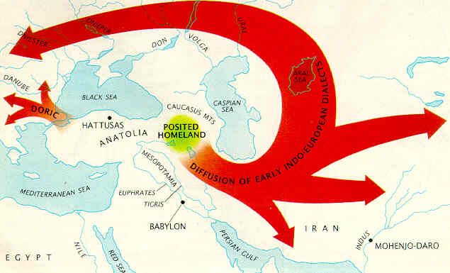
Proto-Indo-Europeans lived on shores of the Black Sea. They were mainly shoreline people with an advanced technology and good social organisation. Thanks to the fact that they had boats they were also fishermen. The Black Sea was very much their Mare Nostrum, 'our sea'. This situation was to a certain extend comparable with that of the Greeks in the Aegean Sea. The fact that they used 'their sea' as a mean of transport and communication means that their language not only spread on all the shores, but also prevented a too great diversification of it. All Greeks claimed that they could understand each other and portrayed all non-Greek speakers as barbarians. This means 'brabrabra'-people, whose language no Greek could understand.
Greeks in the Aegean Sea, PIE around the Black Sea, Gaels around the Irish Sea, Low Germanic around the North Sea, there seems to be a pattern here. However, this is merely a coincidence. People around the Adriatic Sea spoke very different languages for instance. But if a language became spread on most shores of a more or less closed sea, then the language tended to become more uniform. The pace and intensity of development of a common language depended on a number of conditions, such as: ancestral tribal feeling and tradition, intense family contacts, trade and trade monopoly which provided much more added value, similar living conditions, perhaps the presence of a common enemy, and so on.
PIE as a language developed probably somewhere between 20 000 BC and 10 000 BC. In 1997, William Ryan and Walter Pitman published evidence that a massive flooding of the Black Sea occurred about 5600 BC through the Bosphorus. At that time, the Black Sea was a fresh water lake with a water level which was situated some 80 meters below the present day level. The water levels of the Black Sea between 20 000 BC and 10 000 BC are more difficult to assess. It is probable that the beaches moved continuously back and forth, making it tricky to assign an old beach, now probably situated under water, to a certain period. Another consequence is that finding archaeological proof of the very existence of people who lived on the beaches will be arduous. Yet we know that humans like to live near beaches. A lot of food can be found in the sea by fishing. The shores themselves provide shellfish. The hinterland is often full of wild game. Marshlands attract water birds which are easy to capture. It is in that environment that the first PIE people lived.
Columbia University marine geologists William B.F. Ryan and Walter C. Pitman
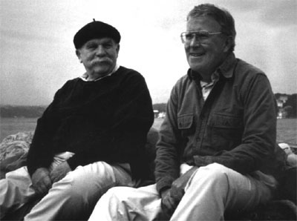
It is essential to understand the living conditions of these first PIE people. By living on the rich shores of a great lake with its numerous large estuaries (such as the Danube delta), the PIE-people could find sufficient food. The Ice Age caused chilling winters but they had the luxury to carefully prepare for winter during the mild summer. As sailors, they were in constant contact with each other and a strong tribal organisation developed. Technology and organisation rendered them superior to the neighbouring land dwelling hunters-gatherers. They had also the advantage of numbers. So, they were able to slowly expand their territory on dry land, mainly to the mild west and south, following upstream the estuaries of big rivers such as the Danube.
The expansion accelerated dramatically at the beginning of the Younger Dryas. (The word Dryas refers to a little Arctic flower. During the period, the flower was found up to the south of France.) The melting of the ice had freed up a lot of land. A lot of PIE people migrated to the northwest. They brought their language: Maglemosian. Others migrated in all possible directions.
A recent hypotheses suggests that one or more extraterrestrial bodies, known as the Clovis Comet, broke up over North America about 12.9 and 11.6 thousand years ago, causing abrupt climatic cooling. Some scientists have proposed this triggered by catastrophic discharge of freshwater into the Atlantic Ocean as the Laurentide Ice Sheet melted, causing a massive die-off of megafauna called the Younger Dryas extinction. The Clovis culture, the people who inhabited North America from about 14,000 years ago, also experienced a marked population decline at the same time.
After this expansion, the PIE language zone was no longer uniform. PIE clans had left the shores of the Black Sea and as the distance grew, communication with their homeland became more and more difficult. Variants of PIE developed locally before the advent of agriculture.
On the shores of the Atlantic Ocean Azelian was spoken, which might be a parent of Basque. Both Azelian and Maglemosian became the most important languages in the thinly populated area of western Europe north of the Pyrenees. The languages evolved and unified regionally because of annual migrations and the winter gatherings during the whole Younger Dryas period (about 4000 years).
Azilian is a name given by archaeologists to an industry of the Epipaleolithic in northern Spain and southern France. It probably dates to the period of the Allerød Oscillation around 10,000 years ago (10,000 BC uncalibrated) and followed the Magdalenian culture. Archaeologists think the Azilian period represents the tail end of the Magdalenian period as the warming climate brought about changes in human behaviour in the area. The effects of melting ice sheets would have diminished the food supply and probably impoverished the previously well-fed Magdalenian manufacturers. As a result, Azilian tools and art were cruder and less expansive than their Ice Age predecessors - or simply different. (Wikipedia) .
Maglemosian was carried by people who genetically resembled people from Serbia and in south Russia. Maglemosian is very old PIE, although a certain local creolisation cannot be excluded.
Maglemosian (ca. 9500 BC–6000 BC) is the name given to a culture of the early Epipaleolithic period in Northern Europe. In Scandinavia, the culture is succeeded by the Kongemose culture.
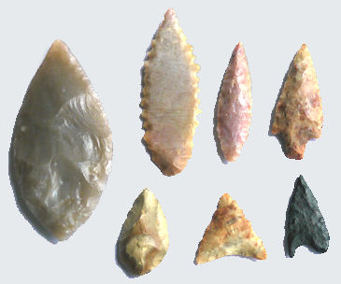
At the beginning of the Holocene, migrations stopped as people more or less settled in their large hunting territories. Their languages gradually diversified locally, more strong dialects appeared. What had been single languages before, when everybody within the tribe could understand everybody, became language groups wherein sometimes the mutual intelligibility had become difficult. Three major language groups emerged in western Europe:
(1) Azelian in west Britain, France and Spain (Atlantic coast).
(2) Maglemosian in Germany, north England and Scandinavia.
(3) Various non-PIE and not related languages existed on the shores of the Mediterranean Sea.
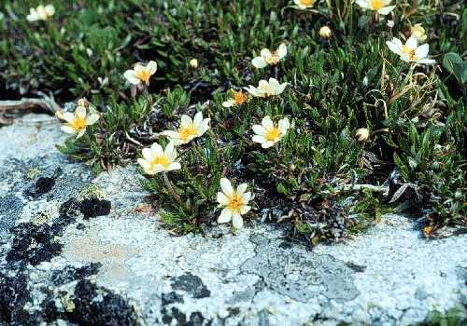<="">
The climate during the Younger Dryas was dry and cold. Europe was covered with steppe with here and there some woods in river dales. Such conditions are ideal for big animals. Wisent, deer, moose etc. can cope with cold weather providing they have enough to eat. Steppe means a lot of grass, so Europe resembled the plains of the American West where bison used to roam in large numbers until the white men almost exterminated them. What the European hunters did was simply following the herds to the north in the spring and back to the south in autumn. For them it was a time of rich pickings.
The Maglemosians had their winter quarter in (modern) Bavaria, the south of Germany, where the wild herds sheltered. These herds were blocked there on their way south because of the ice cap over the Alps and the Rhine in the west. Estimated human population: 50 000-60 000.
The Azilians stayed in the winter in (modern) southwest France for similar reasons. The Pyrenees were covered with ice and proved to be a too difficult obstacle. Estimated population: 80 000-90 000 souls. Azelians could build boats. They were able to sail to Britain and Ireland.
Each winter the languages consolidated. The forming of dialects was prevented by the annual concentration of people.
In the north, close to the remaining ice-cap over Scandinavia, lived some 5000-6000 proto-Scandinavians. Their lifestyle resembled that of the modern Inuit (Eskimos). They would eventually adopt and creolise Maglemosian, transforming it in Northern Maglemosian.
When the Younger Dryas ended, the climate in Europe became much warmer. The steppe quickly transformed into lush woods. The big animals found less grass, less food and their numbers dwindled. Consequently, hunters had much less prey to hunt for, so a period of famine and a reduction of the human population is plausible. This is probably the reason why the Azilian culture showed signs of regression.
At the beginning of the Holocene both Azelians and Maglemosians spread over their territories. Annual migration stopped. Clans became more isolated. Now dialects could slowly develop. (http://www.proto-english.org/o1.html)

Text 7. Two languages emerge in Britain.
Tasks.
- Analyze each paragraph of the text from the point of the logical division.
- Divide the text into logical units. Join several paragraphs if necessary.
- Suggest a suitable title for each paragraph so that you have a detailed plan of the text.
- Express the main idea of each paragraph in a single sentence in English.
- Develop the titles into topic sentences. Join the topic sentences into entity. The précis should not exceed one third of the passage.
- Divide the text into an introduction, principal part and conclusion. Make regroupings if necessary.
- Write a précis of the article. It should not exceed one third of the article.
- Translate the précis into Ukrainian.

Around 8000 BC, Azelian tribes who originated from southern France or northern Spain, colonized most of Doggerland (the North Sea) and Britain. Only the very north of Doggerland was (because of the steadily rising water) occupied by northern Maglemosians. They remained on what became rapidly an island for about 2000 years. The presence of a northern Maglemosian language is required because of the occurrence of the form 'are' of the verb 'to be'. This form is found only in the modern Scandinavian countries, in modern Britain and in one of the oldest PIE languages - the now extinct Hittite language. We think that the 'are' form is very old PIE indeed since it occurs only on the periphery of Europe.
Migrations of Doggerland people when the sea level rose.
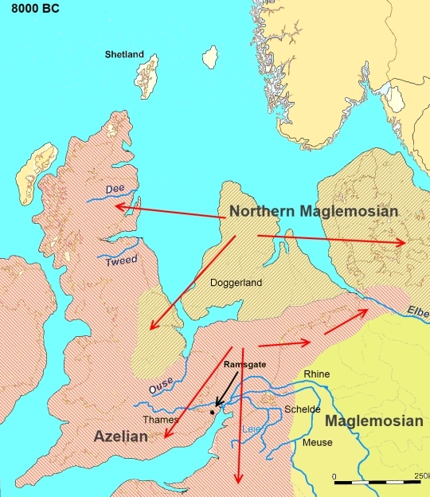
We assume that northern Maglemosian was a strongly divergent dialect of Maglemosian. We suppose that mainstream Maglemosians could barely understand northern Maglemosian. As agriculture advanced, Maglemosian changed into proto-Germanic. Northern Maglemosian resisted longer but eventually changed into proto-Germanic too. However, it kept some archaic features of PIE, which were present earlier in Maglemosian, such as the 'are' form of 'to be'. The northern variant of proto-Germanic was the product of a secondary creolization.
When the ice melted for the last time at the beginning of the Holocene (± 8000 BC), and the sea level rose, all Azelian and northern Maglemosian people, who lived on the North Sea plain, were eventually forced to move to higher ground: to the modern coastal regions of the North Sea. Some of them settled in the east of Britain.
Eight records of local temperature variability on multi-centennial scales throughout the course of the Holocene, and an average of these (thick dark line).
The Doggerland Azelians moved more to the south, to the Low Countries and southeast Britain. Much later, their language would be replaced by proto-Germanic with a 'sind' form of 'to be' and gave birth to a different sort of Germanic, now known as coastal German or Ingvaeonic German.
Maglemosian might have been a language evolution of the ancestor of PIE, mixed with non-PIE substrate words. PIE emanated from the shores of the Black Sea. The northern Maglemosians remained on a northerly latitude. A number of them settled in the northeast of England and in the Midlands. Their language would change later into Scandi-proto-English.
Maurits Gysseling (1919-1994) a twentieth century Belgian linguist and professor, published a paper proposing a very ancient language for Holland and Belgium which was neither German nor Brythonic. He based his hypothesis upon the study of ancient place names in Holland and Belgium. Like many other linguists he studied the Italic features in the Dutch language, not so much in words but in the pronunciation of long vowels. Another indication is the fact that several rivers in the Lowlands (e.g. ijzer, ijssel) seem to have names derived from the Azelian word 'izara'.
Such river names are also found in France (Isère, Oise and others). This made us hypothesize that an important Azelian language zone existed up to the shores of the North Sea.
The Azelian region stretched from the Pyrenees up to the North Sea. Azelian was a non-PIE, pre-agricultural language. Around 5000 BC, in the north, Azelian came under pressure from neighbouring Germanic, the new agricultural language of the north. The Germanic branch of PIE was introduced together with agriculture around 5000BC, first in the north (Moselle valley / Luxembourg). Several centuries later the Occitan-Roman (Italic) branch of PIE was introduced in the south of Europe (east Italy). The south-east Azelians adopted agriculture from the Occitan-Roman speakers and took over in the process their language. In this region, the local variant of Azelian creolized into Ligurian, now a PIE language. A number of substrate, Azelian words and place names, such as 'izara' (river : 'iz' =water + 'a-ra' = running) remained.
Moselle valley / Luxembourg
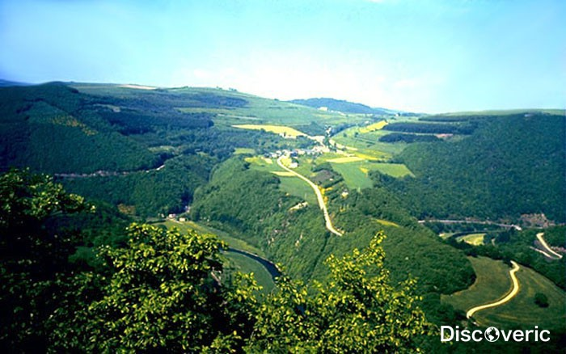
Brythonic creolized (primary creolization) in the southwest of Spain, moved to the north via (modern) Portugal to reach the northwest of Spain and all Atlantic coasts in the north, including west Britain. Brythonic developed probably fully on the French Atlantic coast and in Brittany, from where it was re-exported back, during the Celtic period, to the north of Spain and Portugal.
The Brythonic speakers settled first on the Atlantic coasts and from there began their slow migration inland. At the same time, Germanic speaking farmers moved to the sea. Archaeology confirms that central France was very late in adopting agriculture.
Slowly the Azelian language around the North Sea coasts and down to the Seine river faded out in favour of Germanic. In 'France', south of the Seine, it was gradually replaced by Brythonic, where it became para-Brythonic. We hypothesize that Para-Brythonic was a mixed language, based upon Brythonic but with Azelian, Italic, Occitan and abundantly Germanic words. Compare this with modern English, a language based upon Germanic, but with half its vocabulary consisting of foreign, mainly French words. The reason for that mix is that central France was the last region to be reached by the farmers. Para-Brythonic was the result of a secondary creolization of Brythonic by the former Azelian speakers in central Gaul, Switzerland and a tiny part of northern Italy (south slopes of the Alps). 'Pure' Brythonic, the primary creolization was exported to Britain. In Gaul it became gradually confined to Brittany (Bretagne).
Germanic and Brythonic grew toward each other, eventually squeezing out Azelian completely. The process needed an approximate 1000 years. The Germanic language probably reached its most southern expansion in northern France around 2000 BC. Basque was gradually pushed to the southwest. We believe that it was also around 2000 BC, at the height of the Bronze Age, that place-names ceased to be varying landscape descriptions and became much more fixed, real names.

A nuraghe, a bronze age structure in Italy.
Para-Brythonic gradually re-expanded to the north in France, pushing Germanic back to the north. By the time Julius Caesar arrived, the language border had reached the Somme region. An etymological study of ancient place names to the north of Paris revealed a German origin for many of them. Only the south (the Côte d'Azur) kept its Ligurian language (now a part of Occitan) for a longer time. Occitan expanded further to the west and would push Brythonic back to the northwest. Basque lost gradually most of its territory. The English and Dutch languages (including Frisian) are called coastal Germanic. Their preceding language was Azelian, not Maglemosian as in Germany. The Azelian background of coastal Germanic is responsible for the introduction of many substrate words in proto-Germanic. (http://www.proto-english.org/o2.html)
The Somme region
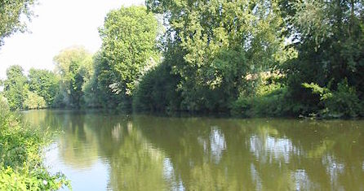

Text 8. Indo-European Linguistics.
Tasks.
- Analyze each paragraph of the text from the point of the logical division.
- Divide the text into logical units. Join several paragraphs if necessary.
- Suggest a suitable title for each paragraph so that you have a detailed plan of the text.
- Express the main idea of each paragraph in a single sentence in English.
- Develop the titles into topic sentences. Join the topic sentences into entity. The précis should not exceed one third of the passage.
- Divide the text into an introduction, principal part and conclusion. Make regroupings if necessary.
- Write a précis of the article. It should not exceed one third of the article.
- Translate the précis into Ukrainian.
The diversification of the parent language into the attested branches of daughter languages is historically unattested. The timeline of the evolution of the various daughter languages, on the other hand, is mostly undisputed, quite regardless of the question of Indo-European origins. [...] As the Proto-Indo-European (PIE) language broke up, its sound system diverged as well, changing according to various sound laws evidenced in the daughter languages.
Proto-Indo-European sound system
Labial | Coronal | Palatal | Plain Velar | Labiovelar
p | t | ky | k | kw
b | d | gy | g | gw
bh | dh | ghy | gh | ghw
Sadly, undisputed, yet completely surrealistic. We no longer believe that the Indo-European languages evolved from the PIE mother language into the modern daughter languages by internal evolution. The time frame is too narrow for that. Diversification is supposed to have started around 2500 BC or a bit earlier if one believes that "The breakup into the proto-languages of the attested dialects is complete at that moment". So, around 2500 BC dialects are supposed beginning to diversify into separate languages. Then how can the linguists justify their reconstructed PIE words without taking in account these supposed dialects? If a word has its reconstructed PIE ancestor, then to which PIE dialect does it belong?
The idea that dialects are the cause of diversification can not be accepted because we found the first Coptic/Egyptian hieroglyphs which date from around 2750 BC and the language evolved but did not really change as the latest version of Coptic, from around 1750 AD, is still similar. QED: Egyptians spoke the same language over a period of 4500 years. This implies that we reject the language tree if it suggests that the PIE languages are the product of a steady evolution.
We believe that creolisation is the answer to the mystery of the fast diversification of PIE. (http://www.proto-english.org/creo.html)
Hieroglyphs typical of the Graeco-Roman period
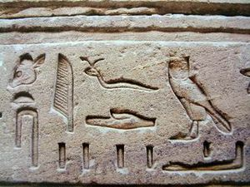
Literature
- A History of Modern and Extinct Celtic Languages. Доступ з: http://h2g2.com/approved_entry/A447824
- Algeo, John. The Origins and Development of the English Language, 6th edition. Wadsworth, 2009. Доступ з: http://www.amazon.com/Workbook-Origins-Development-English-Language/dp/0155070533
- Baugh, Albert C., and Thomas Cable. A History of the English Language, 5th edition. Prentice Hall, 2001.
- Bragg, Melvyn. The Adventure of English: The Biography of a Language. Hodder & Stoughton, 2003. Доступ з: http://www.fantasticfiction.co.uk/b/melvyn-bragg/adventure-of-english.htm
- British Iron Age. Доступ з: http://www.cornwallinfocus.co.uk/culture/celts3.php
- Crystal, David. The English Language. Penguin, 2002.
- Dibdin, Charles” in A Short Biographical Dictionary of English Literature by John William Cousin, London: J. M. Dent & Sons, 1910. Доступ з: http://en.wikisource.org/wiki/Author:Charles_Dibdin
- Gooden, Philip. The Story of English: How the English Language Conquered the World. Quercus, 2009. Доступ з: http://www.goodreads.com/book/show/7305336-the-story-of-english
- Hogg, Richard M., and David Dennison, editors. A History of the English Language. Cambridge University Press, 2006. Доступ з: http://grammar.about.com/od/words/a/historytimeline.htm
- Ilysh В. A. History of English Language. – L., 1973.
- Jespersen О. Modern English Grammar on Historical Principles. – Copenhagen-Longen, 1946–1949. – Vol. 3, 4, 6.
- Lerer, Seth. Inventing English: A Portable History of the Language. Columbia University Press, 2007.
- Mayfield J. The Ancient Germanic Runic Alphabet and Runestones, their Possible Civilization Origins, and their Historic Influence. Доступ з: http://euroheritage.net/runestones.shtml
- McArthur, Tom. The Oxford Companion to the English Language. Oxford University Press, 1992. Доступ з: http://www.avaxhome.ws/ebooks/encyclopedia_dictionary/Oxford_Companion_to_the_English_Language.html
- Millward, C.M., and Mary Hayes. A Biography of the English Language, 3rd ed. Wadsworth, 2011. Доступ з: http://search.barnesandnoble.com/Workbook-for-Millward-Hayes-A-Biography-of-the-English-Language/CM-Millward/e/9780495910091
- Mugglestone, Linda. The Oxford History of English. Oxford University Press, 2006. Доступ з: http://www.english.ox.ac.uk/about-faculty/faculty-members/language-and-linguistics/mugglestone-professor-lynda
- Nist, John. A Structural History of English. St. Martin's Press, 1966. Доступ з: http://www.pairofsachs.net/literature/pdfs/Linguistics_Paper.pdf
- Rastorgueva T.A. History of English. – M., 1983, 2001.
- Reznik R.V., Sorokina T.S., Reznik I.V. А History of the English Language. – M., 2001.
- Roman Britain: Britannia and the Long Arm of Rome. Доступ з: http://www.oglekin.org/Quest/History/After%20the%20Romans%20invade.
- Runes in Scandinavian and Old English Literature. The Cambridge History of English and American Literature in 18 Volumes (1907–21). Volume I. From the Beginnings to the Cycles of Romance. II. Runes and Manuscripts. § 1. The National Germanic Alphabet. Доступ з: http://www.bartleby.com/211/0202.html
- Runic Inscriptions. The Cambridge History of English and American Literature in 18 Volumes (1907–21). Volume I. From the Beginnings to the Cycles of Romance. II. Runes and Manuscripts. § 1. The National Germanic Alphabet. Доступ з: http://www.bartleby.com/211/0203.html
- Scribes and scriptoria. The Cambridge History of English and American Literature in 18 Volumes (1907–21). Volume I. From the Beginnings to the Cycles of Romance. II. Runes and Manuscripts. § 1. The National Germanic Alphabet. Доступ з: http://www.bartleby.com/211/0206.html
- Tablets, parchment, vellum, paper, pens, ink, and binding. The Cambridge History of English and American Literature in 18 Volumes (1907–21). Volume I. From the Beginnings to the Cycles of Romance. II. Runes and Manuscripts. § 1. The National Germanic Alphabet. Доступ з: http://www.bartleby.com/211/0205.html
- The Armenian Alphabet. Доступ з: ndoeuro.bizland.com/project/script/armen.html
- The Cambridge History of English and American Literature. An Encyclopedia in Eighteen Volumes Volume I: English. From the beginning to the cycles of romance. Edited by A. W. Ward & A. R. Waller Bibliographic Record. Доступ з: http://www.bartleby.com/211/index.html
- The Cyrillic Alphabet. Доступ з: http://indoeuro.bizland.com/project/script/cyril.html
- The Glagolitic Alphabet. Доступ з: http://indoeuro.bizland.com/project/script/glago.html
- The Gothic Alphabet. Доступ з: http://indoeuro.bizland.com/project/script/gothi.html
- The Greek Alphabet. Доступ з: http://indoeuro.bizland.com/project/script/greek.html
- The Irish School of Writing. Доступ з: http://www.bartleby.com/211/0206.html
- The Italic and Etruscan Alphabets. Доступ з: http://indoeuro.bizland.com/project/script/itali.html
- The National Germanic Alphabet. The Cambridge History of English and American Literature in 18 Volumes (1907–21). Volume I. From the Beginnings to the Cycles of Romance. II. Runes and Manuscripts. § 1. The National Germanic Alphabet. Доступ з: http://www.bartleby.com/211/0201.html
- The Rise of Rome. Доступ з: http://www.cornwallinfocus.co.uk/culture/celts1.php
- The Roman Alphabet. The Cambridge History of English and American Literature in 18 Volumes (1907–21). Volume I. From the Beginnings to the Cycles of Romance. II. Runes and Manuscripts. § 1. The National Germanic Alphabet. Доступ з: http://www.bartleby.com/211/0204.html
- Who were the Celts? Доступ з: http://www.cornwallinfocus.co.uk/culture/celts.php
- Women in Ancient Celtic Society. Доступ з: http://www.celticquill.com/history/52-women-in-celtic-society

